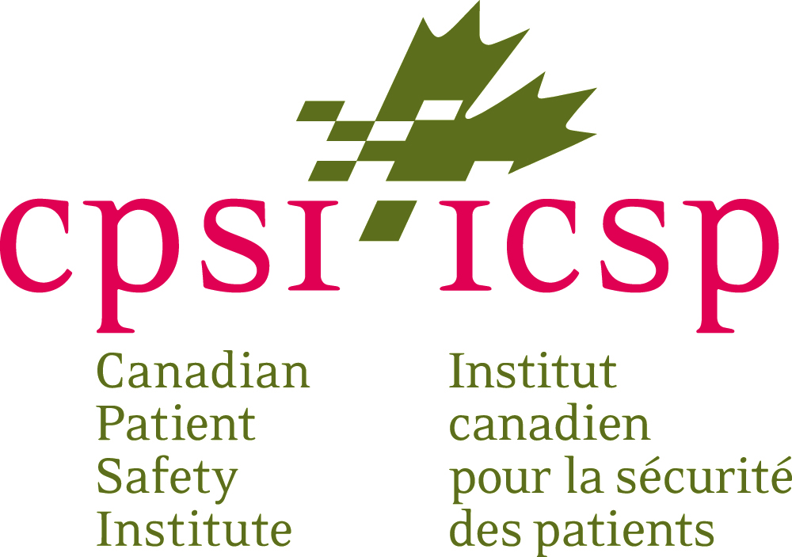

NEWS RELEASE

Surgical Safety Checklist boosted by renewed calls for widespread use in Canadian operating rooms
Edmonton, AB – Calls for a Surgical Safety Checklist to be made a standard part of every surgical procedure performed in Canada are getting louder as more organizations step up.
Led by the Canadian Patient Safety Institute, Alberta Health Services, the Canadian Anesthesiologists' Society and the Operating Room Nurses Association of Canada, and endorsed by half a dozen surgical associations, a Joint Position Statement on the Advocacy and Support for the Use of a Surgical Safety Checklist was released today.
While healthcare providers, teams, and organizations strive to provide safe care, harmful surgical incidents, including wrong site surgeries and surgical items left behind following a surgical procedure, continue to occur in Canada.
A Surgical Safety Checklist is a series of questions that the surgical team will go through at three distinct times: before anesthesia, before incision, and before the patient leaves the operating room. In addition to making sure the standard steps are followed, a checklist encourages better communication between the team members, which has been shown to improve patient safety.
"Healthcare professionals must make every reasonable effort to provide safe care to their patients," said Chris Power, CEO, Canadian Patient Safety Institute. "Patient harm as a result of a surgical safety incident damages public confidence in the healthcare system. Effective use of a Surgical Safety Checklist can facilitate communication among teams and help to avoid never events."
"A Surgical Safety Checklist also reduces patient harm by fostering highly reliable surgical teams which work more effectively together to produce better patient outcomes," said Dr. Giuseppe Papia, Vascular and Endovascular Surgeon and Critical Care Medicine specialist at Sunnybrook Health Sciences Centre, and lead of the Surgical Safety Checklist Working Group.
Surgical safety incidents have a human and monetary cost to patients, families, healthcare providers, institutions, and society. With more than one million surgical procedures performed annually in Canada, and more than half of all hospital patient safety incidents attributed to surgical care, the need to focus on surgical safety rises to the forefront. The Surgical Safety in Canada: A 10-year review of CMPA and HIROC medico-legal data report identified that the most common system and surgical safety issues included inadequate system processes to prevent or mitigate the impact of surgical incidents, non-adherence to surgical safety protocols, and communication breakdowns.​
"Alberta Health Services adopted the Surgical Safety Checklist in 2013 and now uses it in all surgical sites across the province," said Dr. Kathryn Todd, Alberta Health Services Vice President, Research, Innovation and Analytics. "Better communication between healthcare providers and patients pays huge dividends by improving patient safety and patient outcomes. In 2014/15 alone, 'good catches' – or errors averted – were reported in four per cent of all cases as a result of the checklist. Since then, with ongoing monitoring we know that number has fallen to below two per cent."
"With a renewed call for use of a Surgical Safety Checklist, the Canadian Patient Safety Institute and its partners hope to see a reduction in the number of patients harmed as a result of surgical incidents," said Chris Power.
Visit www.patientsafetyinstitute.ca for more information about the Joint Position Statement, Surgical Safety Checklist and other resources available to healthcare providers to keep patients safe.

About Canadian Patient Safety Institute (CPSI)
The Canadian Patient Safety Institute (CPSI) is a not-for-profit organization that exists to raise awareness and facilitate implementation of ideas and best practices to achieve a transformation in patient safety. CPSI reflects the desire to close the gap between the healthcare we have and the healthcare we deserve. CPSI would like to acknowledge funding support from Health Canada. The views expressed here do not necessarily represent the views of Health Canada. www.patientsafetyinstitute.ca

For media inquiries, please contact:
Cecilia Bloxom
Senior Director, Strategic Communications
Canadian Patient Safety Institute
Phone (780) 700-8642

